2009 2BPHY: Electrical Fundamentals Test

Name: ______________________________________________ (40 marks)

- A way to “zap” your friends is to rub your feet on a carpet in summer so as to build up a charge, then you touch a friend and they get “zapped”. Why do you build up a charge when you rub your feet on carpet and what causes the “zap” when you touch your friend? (3 marks)

________________________________________________________________________________________________________________________________________________________________________________________________________________________________________________________________________________________________________________________________________________________________________________________________________________________________________________________________________________________________________________________________________________________________________________________________________________________________________________________________________________________________________________________________________________
- a. Which of the following graphs best represents a non-ohmic conductor? (1 mark)
Answer:

A B C D

- Why did you select this graph? (2 marks) ___________________________________________
_________________________________________________________________________________________________________________________________________________________________________________________________________________________________________________________________________________________________________________________________________________________________________________________________
- Draw the electric field around the following two different situations. (2 marks)
- b.
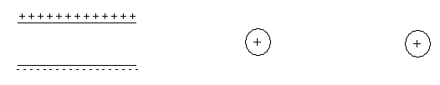

- Label the following circuit to show the direction of electron current. (1 mark)

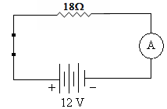

- A lightning bolt contains 6.0 x 10⁹ J of energy which is enough to power a city. If it transfers 30 C of charge to the Earth in 1.5 ms,
a. what was the potential difference produced by the lightning bolt? (2 marks)

b. What is the average power dissipated during the strike? (2 marks)

- a. A force of 8.50 x 10⁻³ N attraction is felt between two charged spheres that are 45 cm apart. If one has a charge of + 0.3 μC, what is the charge on the other? (3 marks)

  - The two spheres are then forced together and allowed to separate to a distance of 30 cm apart. What is the force between the two spheres now? (2 marks)

- A rechargeable battery was charged at a constant current of 600 mA for 9 hours. The average cell potential difference during the re-charge was 1.6V.
- Calculate the amount of charge that passed through the cell. (2 marks)

- Calculate the amount of work done by the charging device. (2 marks)

- A student completes a circuit that includes a mystery box as shown below.
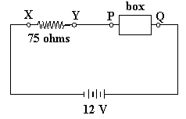

If the potential difference between X and Y is 9.0 volts, which of the following boxes (A - D) is in
the circuit? (3 marks)

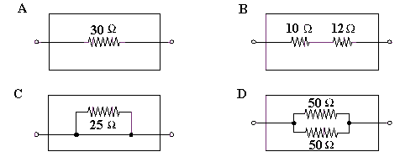

Answer

This space has been left for any working you need to perform.

- The element of an electric jug has a resistance of 60.0 Ω and draws a current of 3.75 A. 1.05 kg of water at a temperature of 20⁰C is in the jug. How long will it take to bring the water to the boil (100⁰C)? Give your answer in minutes. (4 marks)

- You are given the following component.

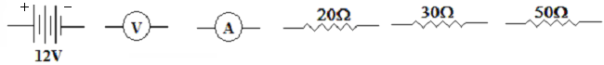
Read all the instructions before you draw the circuit.

Use these components to draw an electrical circuit where the 30Ω and 20Ω resistors are in series. Place the 50Ω resistor in parallel with both of these resistors. Place the voltmeter to measure the potential difference of the 30Ω resistor only and the ammeter to measure the current of the 20Ω resistor only. The battery supplies energy to the whole circuit. (2 marks)

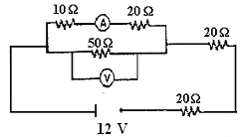
- A student has set up the following circuit in a practical examination. By showing your working below and writing your answers in the spaces provided:

- Determine the total resistance of the circuit. (3 marks) Answer: __________________
b. What is the reading on the voltmeter? (3 marks) Answer: __________________
c. What is the reading on the ammeter? (3 marks) Answer: __________________

BONUS QUESTION (Complete on the back of this sheet).
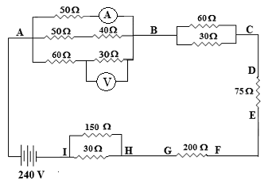
Do not attempt this question until all the others are answered.
Bonus question is worth 5 marks.

Find the reading on the two metres.

